LOOK IT UP:
◊ 1 Peter 3:8 Date:
◊ Ephesians 4:3 Date:
◊ Romans 14:19 Date:
◊ Philippians 2:2-3 Date:

TALK ABOUT IT:

- Who are your mat carriers? What is their faith?

- Are you struggling to live in unity with someone? What can you do to help the situation?

September 11, 2022

“The People of Jesus”

Speaker: Tony Miltenberger

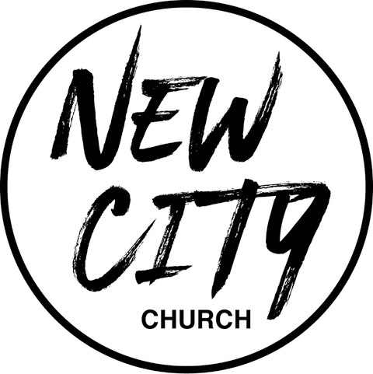

We Exist to: Know God, Love People, and Change Lives
WWW.NCCDayton.org
New City Church Information Center
Welcome to New City Church! We are so glad you could join us today. To help ensure a distraction free worship environment, please be sure your phone ringer is set to vibrate. Also, if you must exit the Worship Center, please do so as quietly as possible. We hope you enjoy today’s worship experience.
- First Time Visitors: If this is your first visit to New City Church, Welcome! Please be sure to visit the Connect Center to drop off your connect card and receive a “thank you” gift for visiting.
Serving Opportunities: If you are interested in volunteering in ministry, you can go online to www.nccdayton.org to the “Volunteering” page and complete a registration form, or you can contact the ministry leader for more information:
  - Children’s Ministry: Courtney Wilson (937)679-2641
  - Praise & Worship: Kyle Fry (937)782-9322
  - Youth Ministry: Pastor Chris Reese (937)344-9706
  - Food Ministry: Diana Leighner (937)241-8318
  - Other Ministries: Jessica Lucas (937)270-8235
2022 Tithes and Offerings Budget
Yearly Needed: $148,617.56
Weekly Needed: $2,858.03
Last Week’s Offering: $3,113.00
Remaining Yearly Needed: $68,847.00

Upcoming Events
*Every Tuesday 5:00-6:00pm Food Ministry-Feed the Community*

*Every Wednesday @ 6:00pm Wednesday Rewind (New City Online)

9/12/22 City Sisters (Door #4) 6:30-8:00pm

9/14/22 Forged Men’s Group (2437 Ontario Ave. Dayton) 6:00-7:30pm

9/17/22 Poker Run for LifeWise Academy Northridge & Open House
(Poker Run registration 10:00-11:30am. Open House 1:00-2:30pm.
Dinner is $10 and served 5-7pm)

9/26/22 City Sisters (Door #4) 6:30-8:00pm

9/28/22 Forged Men’s Group (2437 Ontario Ave. Dayton) 6:00-7:30pm
Connect Center - Volunteers are available at the Connect Center to answer questions or help with activity sign ups. Please stop by, they would love to hear from you.
Message Notes
SCRIPTURE REFERENCE:

• Mark 2:1-12 (NIV)
• Psalm 133:1 (NIV)

- The purpose of Jesus is to bring us into a full life.
  - The pace of Jesus.
  - The place of Jesus.
  - The percentage of Jesus.
  - The people of Jesus.

- “Our time is our life, and our attention is the doorway to our hearts.” -John Mark Comer
- The people who will give you life are the people who will take you places you could never go on your own.
Notes:

*Text-To-Give 937-770-8080

