LOOK IT UP:
◊ Daniel 1 Date:
◊ 1 Peter 2:9 Date:

TALK ABOUT IT:

- What part of the story in chapter 1 of Daniel can you relate to the most?

September 25, 2022

“I Am Special to God”

Speaker: Pastor Chris Reese

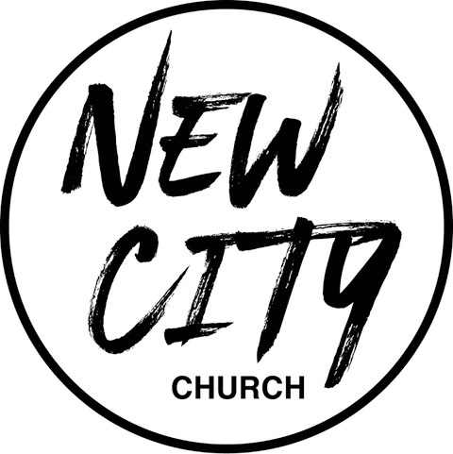

We Exist to: Know God, Love People, and Change Lives
WWW.NCCDayton.org

New City Church Information Center
Welcome to New City Church! We are so glad you could join us today. To help ensure a distraction free worship environment, please be sure your phone ringer is set to vibrate. Also, if you must exit the Worship Center, please do so as quietly as possible. We hope you enjoy today’s worship experience.
- First Time Visitors: If this is your first visit to New City Church, Welcome! Please be sure to visit the Connect Center to drop off your connect card and receive a “thank you” gift for visiting.
Serving Opportunities: If you are interested in volunteering in ministry, you can go online to www.nccdayton.org to the “Volunteering” page and complete a registration form, or you can contact the ministry leader for more information:
  - Children’s Ministry: Courtney Wilson (937)679-2641
  - Praise & Worship: Kyle Fry (937)782-9322
  - Youth Ministry: Pastor Chris Reese (937)344-9706
  - Food Ministry: Diana Leighner (937)241-8318
  - Other Ministries: Jessica Lucas (937)270-8235
2022 Tithes and Offerings Budget
Yearly Needed: $148,617.56
Weekly Needed: $2,858.03
Last Week’s Offering: $2,624.11
Remaining Yearly Needed: $62,622.89

Upcoming Events
*Every Tuesday 5:00-6:00pm Food Ministry-Feed the Community*

*Every Wednesday @ 6:00pm Wednesday Rewind (New City Online)

9/26/22 City Sisters (Door #4) 6:30-8:00pm

9/28/22 Forged Men’s Group (2437 Ontario Ave. Dayton) 6:00-7:30pm

10/3/22 Launch Day for LifeWise Academy-Northridge

10/10/22 City Sisters (Door #4) 6:30-8:00pm

10/12/22 Forged Men’s Group (2437 Ontario Ave. Dayton) 6:00-7:30pm

10/15/22 Night of Worship
Connect Center - Volunteers are available at the Connect Center to answer questions or help with activity sign ups. Please stop by, they would love to hear from you.

Message Notes
SCRIPTURE REFERENCE:

• Daniel 1:1-4 (NLT)
• Daniel 1:5-8
• Exodus 33:17 (NLT)
• Daniel 1:18-21

- Just because something doesn’t mean it is .
- Your in who God says you are, not in who the .
- Daniel in Babylon, but he never let Babylon .

Notes:

*Text-To-Give 937-770-8080

