**LOOK IT UP:**

**◊ 1 Peter 3:15 Date:**

**◊ 2 Timothy 4:5 Date:**

**◊ Colossians 4:5-6 Date:**

**◊ Isaiah 52:7 Date:**

**TALK ABOUT IT:**

1. **What are you willing to do to share the gospel?**

1. **How can you help compel people to Christ?**

**December 18, 2022**

*The Invitation*

*Part 3*

*“Share It Forward”*

Speaker: Jessie Lucas

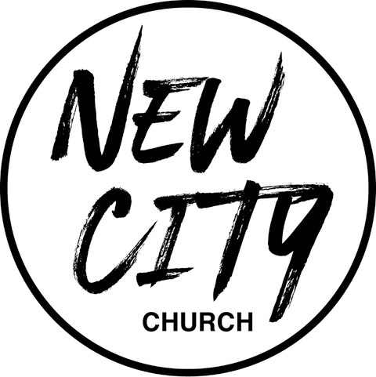

We Exist to: Know God, Love People, and Change Lives

**WWW.NCCDayton.org**

**New City Church Information Center**

*Welcome to New City Church! We are so glad you could join us today. To help ensure a distraction free worship environment, please be sure your phone ringer is set to vibrate. Also, if you* ***must*** *exit the Worship Center, please do so as quietly as possible. We hope you enjoy today’s worship experience.*

* **First Time Visitors:** If this is your first visit to New City Church, Welcome! Please be sure to visit the Connect Center to drop off your connect card and receive a “thank you” gift for visiting.

**Serving Opportunities:** If you are interested in volunteering in ministry, you can go online to [www.nccdayton.org](http://www.nccdayton.org) to the “Volunteering” page and complete a registration form, or you can contact the ministry leader for more information:

* + ***Children’s* *Ministry*:** Courtney Wilson (937)679-2641
  + ***Praise & Worship*:** Kyle Fry (937)782-9322
  + ***Youth Ministry*:** Mario Velasquez (937)867-6341
  + ***Food Ministry:*** Diana Leighner (937)241-8318
  + ***Other Ministries*:** Jessica Lucas (937)270-8235

*2022 Tithes and Offerings Budget*

*Yearly Needed: $148,617.56*

*Weekly Needed: $2,858.03*

*Last Week’s Offering: $3,066.00*

*Remaining Yearly Needed: $33,646.39*

|  |
| --- |
| **Upcoming Events** |
| **\*Every Tuesday 5:00-6:00pm (Door #4)Food Ministry-Feed the Community\***  **12/12/22 City Sisters (Door #4) 6:30-8:00pm**  **12/21/22 Forged Men’s Group (2437 Ontario Ave.) 6:00-7:30pm**  **12/24/22 Christmas Eve Service 6:00-7:00pm (No children’s classes)**  **12/25/22 Christmas Day Service *ONLINE ONLY\***  **1/4/23 Forged Men’s Group (2437 Ontario Ave.) 6:00-7:30pm**  **1/9/23 City Sisters (Door #4) 6:30-8:00pm** |

**Connect Center -** Volunteers are available at the Connect Center to answer questions or help with activity sign ups. Please stop by, they would love to hear from you.

**Message Notes**

|  |  |
| --- | --- |
| **SCRIPTURE REFERENCE:**  **• Mark15:16 (ESV)**  **• 1 Peter 2:9 (NKJV)**  **• Proverbs 11:30 (NKJV)**  **• Luke 14:12-24 (ESV)** |  |

1. **As Christians, we are to the gospel with others.**
2. **The servants would have had to these people to the .**
3. **The wanted the master’s house to be full.**

**Notes:**

**\*Text-To-Give 937-770-8080**