**LOOK IT UP:**

**◊ 1 Corinthians 12:1-10 Date:**

**◊ 1 Corinthians 13:1-2 Date:**

**TALK ABOUT IT:**

1. **Do you know what your spiritual gifts are?**

1. **Are you serving in your gifts?**

**February 5, 2023**

Spiritual Gifts-Part 1

Speaker: Pastor Chris Reese

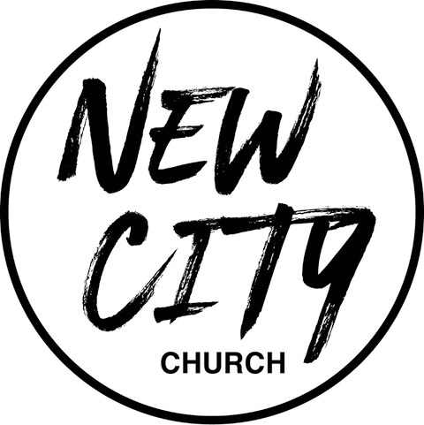

We Exist to: Know God, Love People, and Change Lives

**WWW.NCCDayton.org**

**New City Church Information Center**

*Welcome to New City Church! We are so glad you could join us today. To help ensure a distraction free worship environment, please be sure your phone ringer is set to vibrate. Also, if you* ***must*** *exit the Worship Center, please do so as quietly as possible. We hope you enjoy today’s worship experience.*

* **First Time Visitors:** If this is your first visit to New City Church, Welcome! Please be sure to visit the Connect Center to drop off your connect card and receive a “thank you” gift for visiting.

**Serving Opportunities:** If you are interested in volunteering in ministry, you can go online to [www.nccdayton.org](http://www.nccdayton.org) to the “Volunteering” page and complete a registration form, or you can contact the ministry leader for more information:

* + ***Children’s* *Ministry*:** Courtney Wilson (937)679-2641
  + ***Praise & Worship*:** Kyle Fry
  + ***Youth Ministry*:** Mario Velasquez (937)867-6341
  + ***Food Ministry:*** Diana Leighner (937)241-8318
  + ***Other Ministries*:** Jessica Lucas (937)270-8235

|  |
| --- |
| **Upcoming Events** |
| **2/7/23 Food Ministry-Free Community Meal 5:00-6:00pm (Door #4)**  **2/12/23 Super Bowl Party**  **2/13/23 City Sisters (Door #4) 6:30-8:00pm**  **2/15/23 Forged Men’s Group (2437 Ontario Ave.) 6:00-7:30pm**  **2/21/23 Food Ministry-Free Community Meal 5:00-6:00pm (Door #4)**  **2/25/23 Fitness Group 11:00am-12:00pm (2437 Ontario Ave.)**  **Contact: Mike Jarrett 937-679-6189**  **2/26/23 Spiritual Gifts Test. After service. Lunch provided.**  **2/27/23 City Sisters (Door #4) 6:30-8:00pm** |

**\*Text-To-Give 937-770-8080**

**Connect Center -** Volunteers are available at the Connect Center to answer questions or help with activity sign ups. Please stop by, they would love to hear from you.

**Message Notes**

|  |  |
| --- | --- |
| **SCRIPTURE REFERENCE:**  **•1 Peter 2:9-10 (The Message)**  **• Ephesians 4:11-13 (NIV)**  **• Ephesians 4:12-13 (NCV)** |  |

1. **You are by God.**
2. **God has chosen you and given you . Are you them?**
3. **When we with the spiritual gifts God gave us, the . And we become joined together, , , and .**

**Notes:**