LOOK IT UP:
◊ Ephesians 4 Date:

TALK ABOUT IT:

- What are my spiritual gifts?

- Am I using my spiritual gifts within the Body of Christ to help them grow and mature in Him? And/or to bring others to Christ?

February 26, 2023

A Piece of the Puzzle

Speaker: Cathy Berry

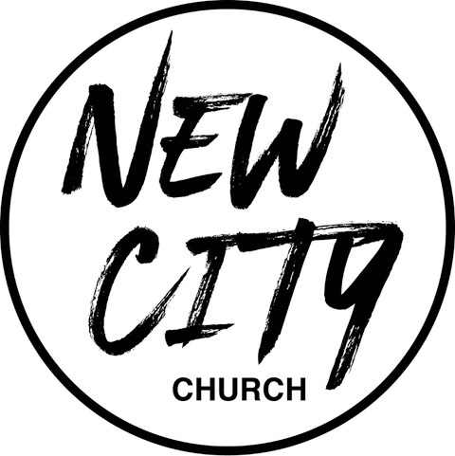

We Exist to: Know God, Love People, and Change Lives
WWW.NCCDayton.org

New City Church Information Center
Welcome to New City Church! We are so glad you could join us today. To help ensure a distraction free worship environment, please be sure your phone ringer is set to vibrate. Also, if you must exit the Worship Center, please do so as quietly as possible. We hope you enjoy today’s worship experience.
- First Time Visitors: If this is your first visit to New City Church, Welcome! Please be sure to visit the Connect Center to drop off your connect card and receive a “thank you” gift for visiting.
Serving Opportunities: If you are interested in volunteering in ministry, you can go online to www.nccdayton.org to the “Volunteering” page and complete a registration form, or you can contact the ministry leader for more information:
  - Children’s Ministry: Courtney Wilson (937)679-2641
  - Praise & Worship: Kyle Fry
  - Youth Ministry: Mario Velasquez (937)867-6341
  - Food Ministry: Diana Leighner (937)241-8318
  - Other Ministries: Jessica Lucas (937)270-8235

Upcoming Events
2/26/23 Spiritual Gifts Test. Directly after service. Lunch provided.

2/27/23 City Sisters (Door #4) 6:30-8:00pm

3/1/23 Forged Men’s Group (2437 Ontario Ave.) 6:00-7:30pm

3/5/23 Fitness Group @ 2437 Ontario Ave. @ 6:00pm
Contact Mike Jarrett @ big.haus.fitness@gmail.com

3/7/23 Food Ministry-Free Community Meal 5:00-6:00pm (Door #4)

3/12/23 Fitness Group @ 2437 Ontario Ave. @ 6:00pm
Contact Mike Jarrett @ big.haus.fitness@gmail.com

3/13/23 City Sisters (Door #4) 6:30-8:00pm

*Text-To-Give 937-770-8080

Connect Center - Volunteers are available at the Connect Center to answer questions or help with activity sign ups. Please stop by, they would love to hear from you.

Message Notes
SCRIPTURE REFERENCE:

•1 Peter 4:10
•Genesis 37-50
•Philippians 4:19
•1 Timothy 2:4
•Ephesians 4:12-13
•Romans 12:6-8
•1 Corinthians 12:12

- We have both gifts and gifts.

- We are to the gift(s) we’ve been given.

- We play a role in God’s story of .

Notes:

