Notes:

***If you consider New City your home church we ask that you consider becoming an official member. If you are interested in becoming a member please fill out the following information, tear at the dotted line and turn it in to the Connect Center. We will contact you with more details.

……………………………………………………………………………………………………………………………

Name:

Phone Number:

Email:

June 11, 2023

Welcome Home

Speaker: Pastor Jason Perkins

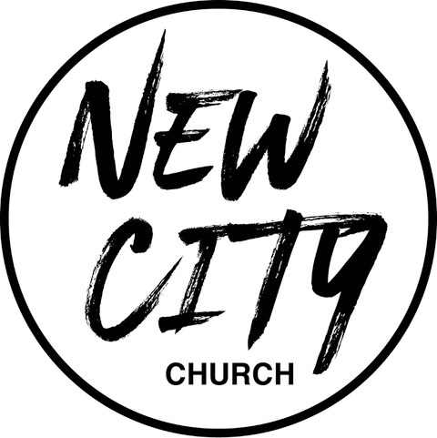

We Exist to: Know God, Love People, and Change Lives
WWW.NCCDayton.org

New City Church Information Center
Welcome to New City Church! We are so glad you could join us today. To help ensure a distraction free worship environment, please be sure your phone ringer is set to vibrate. Also, if you must exit the Worship Center, please do so as quietly as possible. We hope you enjoy today’s worship experience.
- First Time Visitors: If this is your first visit to New City Church, Welcome! Please be sure to visit the Connect Center to drop off your connect card and receive a “thank you” gift for visiting.
Serving Opportunities: If you are interested in volunteering in ministry, you can go online to www.nccdayton.org to the “Volunteering” page and complete a registration form, or you can contact the ministry leader for more information:
  - Children’s Ministry: Courtney Wilson (937)679-2641
  - Praise & Worship: Kyle Fry (937)782-9322
  - Youth Ministry: Mario Velasquez (937)867-6341
  - Food Ministry: Diana Leighner (937)241-8318
  - Other Ministries: Jessica Lucas (937)270-8235

Upcoming Events
6/12/23 City Sisters (Door #3) 6:30-8:00pm

6/20/23 Food Ministry-Free Community Meal 5:00-6:00pm

6/21/23 “Forged” Men’s Group (2437 Ontario Ave.) 6:00-7:30pm

6/26/23 City Sisters (Door #3) 6:30-8:00pm

6/27-6/29 VBS 6:00-8:00pm This is for children 3yrs-6th grade.

7/4/23 Food Ministry-Free Community Meal 5:00-6:00pm

7/5/23 “Forged” Men’s Group (2437 Ontario Ave.) 6:00-7:30pm

7/10/23 City Sisters (Door #3) 6:30-8:00pm

*Text-To-Give 937-770-8080

Connect Center - Volunteers are available at the Connect Center to answer questions or help with activity sign ups. Please stop by, they would love to hear from you.

Message Notes
SCRIPTURE REFERENCE:

•Isaiah 35:1-10

Notes:

