October & November Events at New City Church
10/31/23 Treat-Your-Streets at the Blast Center (2437 Ontario Ave.)
6:00-8:00pm

11/05/23 – Non-Perishable Food Drive Begins

11/7/23 Free Community Meal 5:00pm – 6:00pm

11/8/23 Forged Men’s Group (2437 Ontario Ave.) 6:00pm – 7:30pm

11/10/23 ALL IN Youth Conference 7:00pm – 10:00pm

11/11/23 ALL IN Youth Conference 9:00am – 5:00pm

11/13/23 City Sisters (Door #3) 6:30-8:00pm

11/21/23 Free Community Meal 5:00pm – 6:00pm

11/22/23 Forged Men’s Group (2437 Ontario Ave.) 6:00pm – 7:30pm

11/27/23 City Sisters (Door #3) 6:30-8:00pm

Event Help Needed
DONATIONS NEEDED

- Treat Your Street at the Blast Center on 10/31/23
- Donations of Candy is needed for this event. Please see Jessie Lucas for Information.

VOLUNTEERS NEEDED

- Treat Your Street at the Blast Center on 10/31/23 is looking for volunteers to help pass out candy. If you are interested, please contact Jessie Lucas at (937) 270-8235

- All In Youth Conference Event (November 10-11) is looking for volunteers to help in all areas of the event. If you are interested, please contact Mario Velasquez at (937) 867-6341

October 29, 2023

Taming the Tongue
Bless With Your Words

Speaker: Pastor Jason Perkins

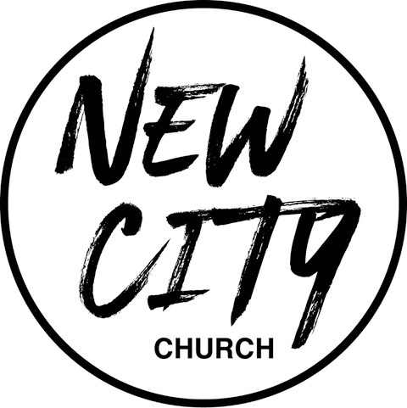

We Exist to: Know God, Love People, and Change Lives
WWW.NCCDayton.org

New City Church Information Center
Welcome to New City Church! We are so glad you could join us today. To help ensure a distraction free worship environment, please be sure your phone ringer is set to vibrate. Also, if you need to exit the Worship Center, please do so as quietly as possible. We hope you enjoy today’s worship experience.
- First Time Visitors: If this is your first visit to New City Church, Welcome! Please be sure to visit the Connect Center to drop off your connect card and receive a “thank you” gift for visiting.
Serving Opportunities: If you are interested in volunteering in ministry, please contact the ministry leader (listed below) for more information:

  - Pastor: Jason Perkins: (937)244-5010
  - Children’s Ministry: Courtney Wilson (937)679-2641
  - Praise & Worship: Kyle Fry (937)782-9322
  - Youth Ministry: Mario Velasquez (937)867-6341
  - Food Ministry: Diana Leighner (937)241-8318
  - Other Ministries: Jessica Lucas (937)270-8235
If you consider New City your home church, consider becoming a member. If you are interested in becoming a member, please fill out the following information, and submit to the Connect Center. We will contact you with additional details.

NAME:

PHONE #:

EMAIL:

PREFERRED CONTACT METHOD: PHONE EMAIL

TEXT TO GIVE: (937) 770-8080

SCRIPTURE REFERENCE:
Psalms 34:1
Psalms 56:3
Proverbs 10

My Notes:

