December Events at New City Church
12/3/23 Collecting Non-Perishable Food

12/5/23 Community Meal 5:00pm – 6:00pm

12/6/23 Forged Men’s Group (2437 Ontario Ave) 6:00pm – 7:30pm

12/10/23 Collecting Non-Perishable Food

12/11/23 City Sisters (Door #3) 6:30pm – 8:00pm

12/17/23 Collecting Non-Perishable Food

12/19/23 Community Meal 5:00pm – 6:00pm

12/20/23 Forged Men’s Group (2437 Ontario Ave) 6:00pm – 7:30pm

12/24/23 Christmas Eve Candlelight Service 5:00pm. No Morning Service.

12/25/23 City Sisters - Cancelled

Event Help Needed
DONATIONS NEEDED

- Donations are now being accepted for non-perishable food items. Donations may be dropped off in the barrels located in the front lobby area.

Special Note
Sunday, December 24

We will not have Sunday Morning Service on Christmas Eve this year. Instead, we will have a candlelight service starting at 5:00pm.

December 3, 2023

Advent
Hope

Speaker: Pastor Jason Perkins

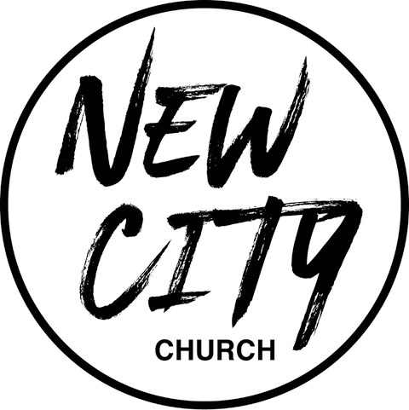

We Exist to: Know God, Love People, and Change Lives
WWW.NCCDayton.org

New City Church Information Center
Welcome to New City Church! We are so glad you could join us today. To help ensure a distraction free worship environment, please be sure your phone ringer is set to vibrate. Also, if you need to exit the Worship Center, please do so as quietly as possible. We hope you enjoy today’s worship experience.
- First Time Visitors: If this is your first visit to New City Church, Welcome! Please be sure to visit the Connect Center to drop off your connect card and receive a “thank you” gift for visiting.
Serving Opportunities: If you are interested in volunteering in ministry, please contact the ministry leader (listed below) for more information:

  - Pastor: Jason Perkins: (937)244-5010
  - Children’s Ministry: Courtney Wilson (937)679-2641
  - Praise & Worship: Kyle Fry (937)782-9322
  - Youth Ministry: Mario Velasquez (937)867-6341
  - Food Ministry: Diana Leighner (937)241-8318
  - Other Ministries: Jessica Lucas (937)270-8235
If you consider New City your home church, consider becoming a member. If you are interested in becoming a member, please fill out the following information, and submit to the Connect Center. We will contact you with additional details.

NAME:

PHONE #:

EMAIL:

PREFERRED CONTACT METHOD: PHONE EMAIL

TEXT TO GIVE: (937) 770-8080

SCRIPTURE REFERENCE:
Romans 15:11-14

My Notes:

