March & April Events at New City Church
3/24/24 Membership Classes Session 4 (Door #3) 3:00pm – 5:00pm

3/25/24 City Sisters (Door #3) 6:30pm – 8:00pm

3/27/24 Forged Men’s Group (Front Doors of Church) 6:00pm – 7:30pm

3/31/24 Baptism Service

4/2/24 Community Meal 5:00pm – 6:00pm

4/8/24 City Sisters (Door #3) 6:30pm – 8:00pm

4/10/24 Forged Men’s Group (Front Doors of Church) 6:00pm – 7:30pm

4/13/24 Volunteers Cleaning Lower Level of Church at 10am

4/16/24 Community Meal 5:00pm – 6:00pm

4/22/24 City Sisters (Door #3) 6:30pm – 8:00pm

4/24/24 Forged Men’s Group (Front Doors of Church) 6:00pm – 7:30pm

4/29/24 Good Friday Service at 7:00pm

Volunteers Needed
As New City Church steps into the New Year, we are reminded of Christ’s instructions given to us in Matthew 28:19-20 to “Go ye therefore, and teach all nations, baptizing them in the name of the Father, and of the Son, and of the Holy Ghost: Teaching them to observe all things whatsoever I have commanded you: and, lo, I am with you always, even unto the end of the world. Amen”.

New City Church has always sought to embody these commands through our ministries of serving, giving, and teaching. This is not a task that can be done by one or two people. We need an army of willing servants to help carry out the cause of Christ. We cannot grow the hands and feet of Jesus without the support of our church family. New City is asking each person to prayerfully consider serving in a ministry during 2024. Thank you.

- Pastor: Jason Perkins (937)244-5010
- Children’s Ministry: Courtney Wilson (937)679-2641
- Praise & Worship: Kyle Fry (937)782-9322
- Youth Ministry: Mario Velasquez (937)867-6341
- Hospitality: Kris Wilson
- Media: Gene Whittington (937)467-5332
- Food Ministry: Diana Leighner (937)241-8318
- Other Ministries: Jessica Lucas (937)270-8235

www.nccdayton.org
Palm Sunday

Speaker: Pastor Jason Perkins

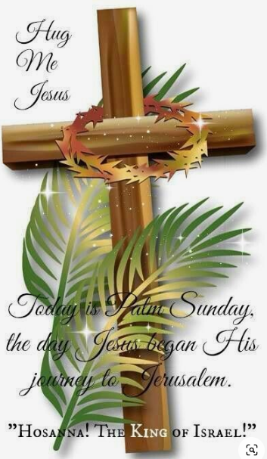

Sunday, March 24, 2024

New City Church Information Center
Welcome to New City Church! We are so glad you could join us today. To help ensure a distraction free worship environment, please be sure your phone ringer is set to vibrate. We hope you enjoy today’s worship experience.
First Time Visitors

If this is your first visit to New City Church, Welcome! Please be sure to visit the Connect Center to drop off your connect card and receive a “thank you” gift for visiting.

3 Ways to Give

Give Online: https://www.newcitychurchdayton.org/giving/
Text to Give: 937-770-8080
By Mail: New City Church 4800 N. Dixie Dr. Dayton, Ohio 45414

Church Cleaning Day

On April 13th at 10am, we will be meeting at the church to clean the lower level. We are requesting for volunteers to please sign up to help with various tasks that need to be completed. Sign-up sheets are at the Welcome Center.

Charter Sunday, April 7th

Services on Sunday, April 7th will start at 10:00am.
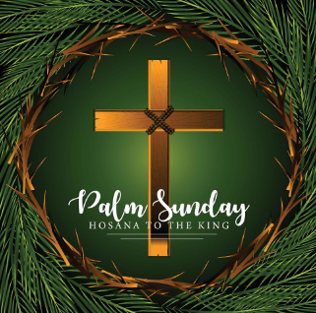

Please Note: Pastor Jason will be honoring Sabbath starting on Sunday at 3:00pm. He will not be accessible until Tuesday Mornings. If you have an immediate need, please contact Jessie Lucas. Thank you!

Scripture Reference

John 12:12-19 (NIV)

¹² The next day the great crowd that had come for the festival heard that Jesus was on his way to Jerusalem. ¹³ They took palm branches and went out to meet him, shouting,
“Hosanna!” “Blessed is he who comes in the name of the Lord!”
“Blessed is the king of Israel!”

¹⁴ Jesus found a young donkey and sat on it, as it is written:
¹⁵ “Do not be afraid, Daughter Zion;
see, your king is coming,
seated on a donkey’s colt.”
¹⁶ At first his disciples did not understand all this. Only after Jesus was glorified did they realize that these things had been written about him and that these things had been done to him.
¹⁷ Now the crowd that was with him when he called Lazarus from the tomb and raised him from the dead continued to spread the word. ¹⁸ Many people, because they had heard that he had performed this sign, went out to meet him. ¹⁹ So the Pharisees said to one another, “See, this is getting us nowhere. Look how the whole world has gone after him!”
NOTES

